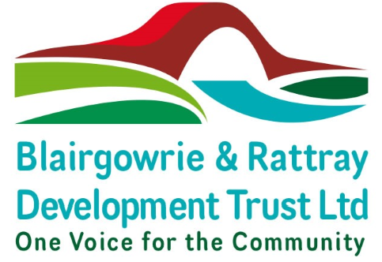

**DRAFT Minutes of the 5th Annual General Meeting of Blairgowrie & Rattray Development Trust Limited**

**Held in Blairgowrie Town Hall on Sunday 16th October 2022 at 4.15pm**

**Present:** Teresa Donaldson – Chair, William Wilson - Director, Saragh Penfold - Director, Linda Retson - Director, Bob Swan - Director

# In attendance

Trust ordinary members - twelve

Non–members in attendance – three

1. **Welcome & Apologies** – Teresa Donaldson welcomed everyone. Apologies were recorded as follows: Caroline Shiers, Liz Mason, Jacqueline & John Edwards, Jessie Shaw.

1. **Approval of Previous Minutes –** The minutes 4th BRDT AGM held on 16th December 2021 were approved. Proposed by B Swan, Seconded by W Wilson.

1. **Reports & Accounts Presentation –** These had been made available prior to the AGM and were accepted by all with no questions raised. T Donaldson provided a summary of activity over the year and thanked everyone for their contribution.

The accounts were Proposed by W Wilson and Seconded by L Retson.

The Accounts were approved.

# 4. Proposal of Resolutions

The Company Secretary announced the Resolutions:

4.1 To elect Robert Swan as a Director. Proposed by S Hart, seconded by L Retson and passed unanimously.

4.2 To elect Teresa Donaldson as a Director. Proposed by S Hart, seconded by L Retson and passed unanimously.

4.3 To elect William Wilson as a Director. Proposed by S Hart, seconded by L Retson and passed unanimously.

## 5.0 Appointment of Co-opted Directors as per Articles 83-84

5.1 To appoint Geoffrey Thomson as a Director. Proposed by A Shaw, seconded by B Swan and passed unanimously.

5.2 It was confirmed L Retson is a member and hence is already a Director.

5.3 To appoint S Penfold as a Director. Proposed by A Shaw, seconded by B Swan and passed unanimously.

5.4 To appoint T Watchorn as a Director. Proposed by A Shaw, seconded by B Swan and passed unanimously.

## Any Other Competent Business

None

## 6.0 Close

The Annual General Meeting closed at 16.35pm with the date of the next AGM set at 15 October 2023.