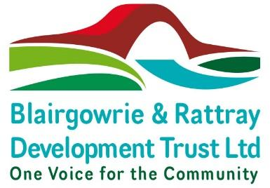**NOTICE OF ANNUAL GENERAL MEETING 2023**

**Rattray Bowling Club**

**At 6pm om Wednesday 20th December 2023**

Notice is hereby given that the 6th Annual General Meeting of The Blairgowrie & Rattray Development Trust will be held at Rattray Bowling Club at 6pm on Wednesday 20th December 2023

Business to be dealt with at the meeting is:

1. Welcome and apologies
2. Minutes of AGM 16th October 2022 - Approval
3. Presentation of the Annual Trustees Report & Accounts
4. Proposal of Resolutions:

As Special Resolutions to amend the Articles of Association:

* 1. Contents List
  2. Membership Subscription – Articles 31 and 32
  3. Director’s Meetings – Article 101

As Ordinary Resolutions

* 1. To elect Len Seal as a director

Appointment of Co-opted directors:

* 1. To appoint Linda Tait as a director
  2. To appoint Tracie Dick as a director

1. Presentation on revised Structure and plans for 2024

Close

**A member of The Blairgowrie & Rattray Development Trust Limited (“the Company”) eligible to attend and vote at the Members’ Meeting is entitled to appoint another person as proxy to attend and vote on a poll in their place.**

**A form of proxy is enclosed and must be lodged at the Company’s registered office at least 48 hours before the meeting.**